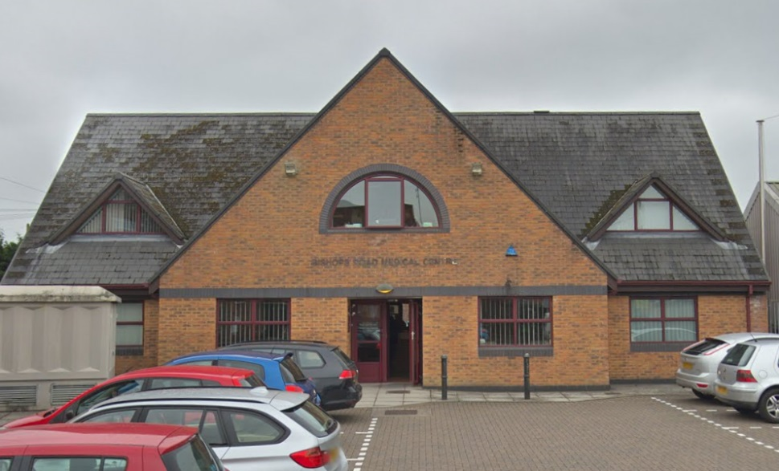

Bishops Road Medical Centre
1 Bishops Road
Whitchurch
Cardiff
CF14 1LT

Tel: 029 20522355
Fax: 029 20522686
FOLLOWING GOVERNMENT GUIDELINES
DURING THE PANDEMIC WE WILL OPERATE A PREDOMINENTLY TELEPHONE TRIAGE SYSTEM
 | AM | PM
Monday | 8.30am – 11.30am On the day only (Face to Face or Telephone) | From 3:00pm Pre-bookable in advance
Tuesday | 8.30am – 11.30am On the day only (Face to Face or Telephone) | From 3:00pm Pre-bookable in advance
Wednesday | 8.30am – 11.30am On the day only (Face to Face or Telephone) | From 3:00pm Pre-bookable in advance
Thursday | 8.30am – 11.30am On the day only (Face to Face or Telephone) | From 3:00pm Pre-bookable in advance
Friday | 8.30am – 11.30am On the day only (Face to Face or Telephone) | From 3:00pm Pre-bookable in advance
Reception is open from 8.00am until 6.00pm

Tongwynlais Surgery
1 St. Michael’s Close
Tongwynlais
Cardiff
CF15 7LB

Tel: 029 20810311
Monday | Closed
Tuesday | 8:30am – 10:30am On the day Face to Face or Telephone and Pre-bookable in advance
Wednesday | 8:30am – 10:30am On the day Face to Face or Telephone and Pre-bookable in advance
Thursday | Closed
Friday | 8:30am – 10:30am On the day Face to Face or Telephone and Pre-bookable in advance
Reception is open from 8:30am until 1.00pm

The surgery is closed at weekends and on all public bank holidays
Dr David L. Jones (male), MB BCh MRCGP, University Hospital of Wales (1990)
Dr Mared Rhys (female), MB BCh DRCOG MRCCP DFFP, University Hospital of Wales (1990)
Dr Jassim Mohamed Ali (male) MD, MRCGP, DCH, DPD, Lviv 2002)

The Practice Team
Nurses | Sister Kim Richards and Sister Sharon Evans  If you need any of the following services, please arrange to see the practice nurse:- Annual diabetic review, annual asthma review, annual epilepsy review, hypertension review, child immunizations, cervical smears, diet advice and smoking cessation advice, contraception advice/pill checks/injection, minor injuries. Holiday vaccinations are available; there may be a charge for certain vaccines.
Health Care Assistant | Michelle Sutton
Practice Manager | Julie Brewerton
Deputy Practice Manager | Tracy Leask
Administration Team  Reception Team | Admin Supervisor: Jay Andrews,  Admin Team: Karen Evans, Bridget Beecham, Debra Parfitt, Sam Jones  Reception Manager: Collette England  Receptionists: Sue Lawrence (Carer’s Champion), Susan Harding, Sonia Jefferis, Tracy Taylor, Rachel Beckley, Hayley Masters, Chloe Ghanizadeh.
Health Authority Staff Attached to the Practice
Health Visitors |  | Kerry Screen is our Health Visitor and is available to give advice on the health and welfare of our under 5’s. Kerry is based at Radyr clinic and can be reached on Cardiff 02920 613685.
District Nurses |  | Sister Juliet Sharpless heads our District Nursing Team and is available to give nursing care to housebound patients in their own homes at the request of the doctors

If you would like to speak to a receptionist in private, this can be arranged.

Please notify us of any change of name/address/telephone number so that we can update our records.
Practice Area
Patients are accepted from most of North Cardiff i.e. Llandaff North, Whitchurch, Gabalfa, Rhiwbina, Tongwynlais, Taffs Well and Morganstown.
How to Register
If you have your medical card (fp58) please bring this with you, alternatively you will be given a form to fill in, you will need your previous doctors details. You will be asked to fill in a questionnaire about your medical history. If you are from overseas or a British National returning to the UK you will be asked to supply documentary evidence of the duration of your stay and your residency.
Complaints or Suggestions
We operate a complaints procedure, details of which are available at reception. We aim to provide a high quality service to all our patients, and our practice manager would be interested in hearing your suggestions both positive and negative.
Why does the NHS collect information about you?
Your Doctor and the team of Health Professionals caring for you keep records about your health and any treatment or care you receive from the NHS. This information will either be written down (manual records) or held on computer (electronic records). These records are then used to guide and manage the care you receive. You may also be receiving care from organizations outside the NHS (like social services). If so we may need to share some information about you so that everyone involved in your care can work together for your benefit. Whenever this is necessary, your information will be handled in the strictest of confidence and will be subject to the principles of confidentiality.

Child Health
The practice provides a full immunisation service and runs child development clinics. Appointments are necessary Bishops Road Wednesday: 12.30pm–1.15pm
Ante Natal Care
All ante natal care is at Bishops Road run by the Community Midwives by appointment only. Please telephone the Surgery for an appointment.
Bishops Road Monday: 1.00pm – 3.00pm
Family Planning
After initial consultation with the Doctor, follow up pill checks and prescription issues will be undertaken by the Practice Nurse.
Please see the Practice Nurse if you require the contraceptive injection.
Minor Surgery
Minor surgery is performed by appointment after consultation with the doctors.
Temporary Residents
The Doctors will see friends and relatives of existing patients providing there are free appointments. A temporary resident form must be completed before the patient can be seen.
Visitors from Abroad
Visitors from abroad will be treated privately unless they present with an urgent/acute condition.
Publication Scheme
In line with current regulations, this scheme is a guide to information which can be made available to the public about our Practice and its General Practitioners. If you are interested in obtaining a copy please ask at reception.
Blood Tests
The Practice uses the services of a Phlebotomist to take blood samples when requested by a doctor, the service is available at Bishops Road Medical Centre on a Monday, Tuesday, Thursday and Friday mornings and Tongwynlais Surgery on Wednesday mornings an appointment is always necessary. Please be advised that the phlebotomist is only trained to take blood samples and not to give medical advice.
Test Results and Telephone Advice
Our reception staff have been trained to give results under the guidance of the doctors and your result will be available 7 days after your blood test. Please telephone us after 2.30pm Monday to Friday for the results.
Home Visits
If you require a home visit please, where possible, telephone before 10.30am. You will be required to give the receptionist some indication of the problem. Our home visit guidelines are:-
- GP visit recommended
Home visiting makes clinical sense and is the best way of giving medical opinion in cases involving:
- The terminally ill.
- The truly housebound patient for whom travel to premises by car would cause deterioration in their medical condition.
- GP visit may be useful
Following a conversation with a health professional, it may be agreed that a seriously ill patient may be helped by a GP’s visit.
- GP visit is not usual
In most of these cases a visit would not be an appropriate use of your GP’s time or best for you:
- Heart Attack – severe crushing chest pain. The best approach is to call 999.
- Stroke – Sudden weakness or numbness of the face arm or leg on one side of the body, sudden difficulty speaking or understanding spoken language, sudden loss or blurring of vision. Call 999
- Common symptoms of childhood: fevers, cold, cough earache, headache, diarrhoea /vomiting and most cases of abdominal pain. These patients are usually well enough to travel to the surgery. It is not harmful to take a child with fever outside.
- Adults with common problems, such as cough, sore throat, influenza, general malaise, back pain and abdominal pain are also readily transportable to the doctor’s surgery. Transport arrangements are the responsibility of the patients or their carers.
Out of Hours
The Doctors in this practice are responsible for the care of its patients during the hours of 8.00am – 6.30pm Monday to Friday. The cover outside of these hours is the responsibility of Cardiff Local Health Board. If you need a Doctor in an emergency when the practice is closed please telephone the surgery and you will be given a telephone number to contact
Repeat Prescriptions
These may be arranged at the discretion of your doctor. You can request your prescription either by placing your pre- printed request slip in the box provided just inside the front door, posting your request or using the local pharmacy collection services. It may be possible to order your repeat prescriptions on line please ask at reception for details. Please allow 48 (working) hours for collection. If you are requesting by post and enclose a stamped addressed envelope, please allow at least a week for your prescription to reach you.
WE DO NOT TAKE TELEPHONE REQUESTS FOR REPEAT PRESCRIPTIONS!
Training of Medical Students
On occasions medical students sit in on consultations. If you are not happy to have them present at your consultation, please inform the Doctors.
Access to Medical Records
In line with current legislation, you have a right to access your medical records. For further details please contact either the Administrators/Secretary or Practice Manager.
Non NHS Examinations
Medical examinations for special purposes i.e. elderly drivers, pre-employment, fitness for certain sports, HGV, taxi medicals etc., are done outside consulting hours. Please contact the surgery for an appointment time. A fee will be charged at the recommended B.M.A. rate.
What we will do for you
We will treat all patients with courtesy and respect, regardless of their race, gender, social class, age, religion, sexual orientation or appearance, disability or medical condition. We will respect our patients’ privacy and confidentiality at all times, ensure our premises are welcoming, easy for patients to find their way around and appropriate to the needs of users, including the disabled. All members of the primary care team are dedicated to providing health service which meet our patient’s needs.
What you can do for us
Be courteous and polite to staff at all times.
Patients will be removed from our practice list if they are violent or use aggressive, rude or threatening behaviour to staff or other patients.
Endeavour to attend appointments/surgery at the correct time. Give us at least 24 hours’ notice when cancelling a booked appointment to enable it to be utilized by another patient.

This leaflet is available in large print – please ask at reception

Cardiff and Vale University Health Board
ACCESS STANDARDS 2019

A new set of standards were announced by the Minister for Health and Social Services in March 2019 that are aimed to raise and improve the level of service for patients in Wales from their GP practices.
These standards are:
- People receive a prompt response to their contact with a GP practice via the telephone.

- Practices have the appropriate telephony systems in place to support the needs of people avoiding the need to call back multiple times and will check that they are handling calls in this way.

- People receive bilingual (Welsh and English) information on local and emergency services when contacting a practice.

- People can use a range of options to contact their GP practice and to make an appointment.

- People are able to email a practice to request a non-urgent consultation or a call back.

- People are able to access information on how to get help and advice.

- People receive the right care at the right time in a joined up way that is based on their needs.

- Practices understand the needs of their patients and use this information to anticipate the demand on its services.

Cardiff and Vale University Health Board will be supporting your GP practice to ensure these standards are achieved by March 2021.

